**Aim:- Data Visualization from ETL Process.**

**Step 1: Create charts showing Units in Stock by Product and Total Sales by Year.**

1. Drag UnitsInStock from the Field pane (the Fields pane is along the right of the

screen) onto a blank space on the canvas. A Table visualization is created. Next, drag

ProductName to the Axis box, found in the bottom half of the Visualizations pane.

Then we then select Sort By > UnitsInStock using the skittles in the top right corer of

the visualization.

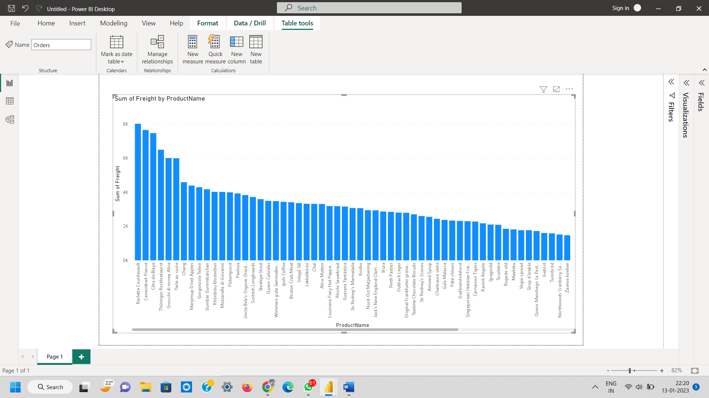

2. Drag OrderDate to the canvas beneath the first chart, then drag LineTotal (again, from

the Fields pane) onto the visual, then select Line Chart. The following visualization is

created.

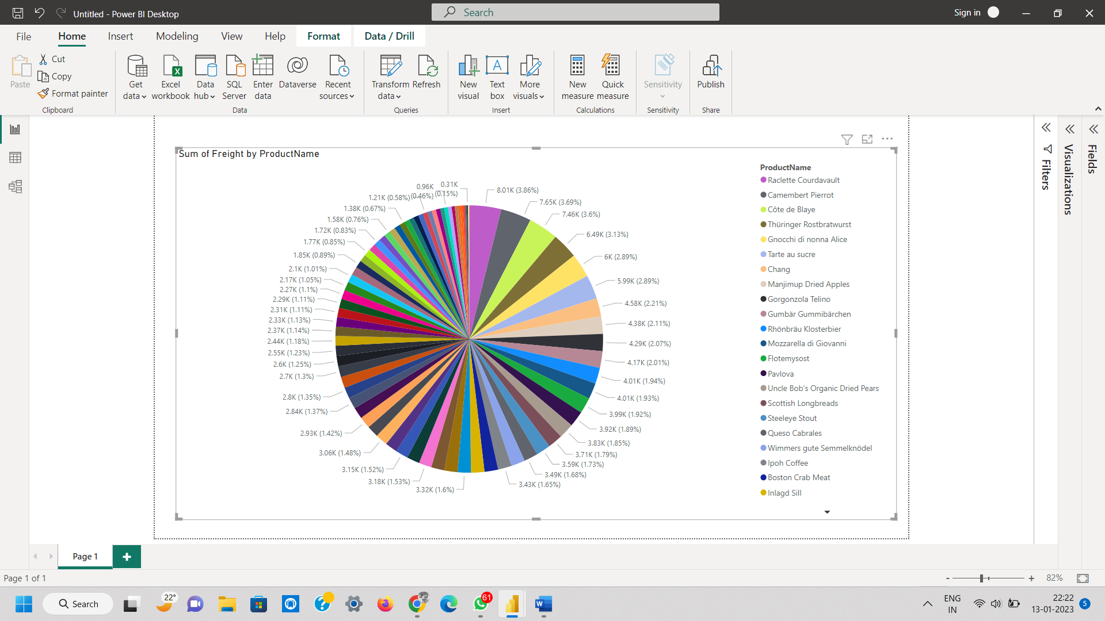

3. Next, drag ShipCountry to a space on the canvas in the top right. Because you selected

a geographic field, a map was created automatically. Now drag LineTotal to the Values

field; the circles on the map for each country are now relative in size to the LineTotal

for orders shipped to that country.

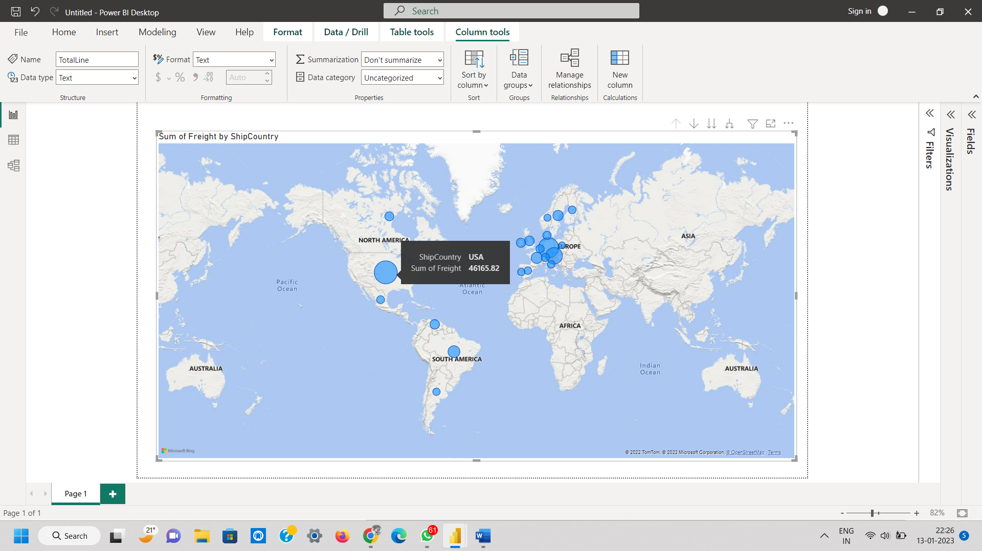

**Step 2: Interact with your report visuals to analyze further.**

Power BI Desktop lets you interact with visuals that cross-highlight and filter each other to

uncover further trends.

1. Click on the light blue circle centered in Canada. Note how the other visuals are

filtered to show Stock (ShipCountry) and Total Orders (LineTotal) just for Canada.

